Lab 4-Sensors

Tutorial adapted from <https://www.instructables.com/Pocket-Size-Ultrasonic-Measuring-Tool-With-ESP32/>

## Learning Outcomes:

* Learn how to work a sensor
* Learn about the ultrasonic sensor
* Connect with the sensor using Bluetooth

### Background:

Electrical engineers use all kinds of sensors for a variety of applications. It could be a LIDAR module on a self-driving car or a thermocouple in an indoor air conditioning system. Regardless, the purpose of sensors is to record some measurement from the outside world, turn it into an electrical signal, which is then analyzed by a device. [Different Types of Sensors and their Uses (ie Electrical Sensors)](https://www.thomasnet.com/articles/instruments-controls/sensors/#applications)

Sensors first use an electro-mechanical device to measure something in the real world. The sensor then converts the real-world measurement into a digital or analog signal. A digital signal is composed of bits. Each bit is either a low voltage, 0’s or high voltage, 1’s. This is what computational devices like your computer use. An analog signal can exist within a range of voltages. Regardless, this signal is typically sent to a controller which then processes that signal and will then act on the world.

With the advent of the internet of things ([Internet of things](https://en.wikipedia.org/wiki/Internet_of_things)) sensors are more important than ever. It’s important to understand how they work and use them effectively. When using a sensor that you’re unfamiliar with it is useful to refer to its datasheet. You can find all sorts of useful information there. For our AutonoMouse we will be using HC-SR04 which is an ultrasonic sensor. Read more about it here: [How HC-SR04 Ultrasonic Sensor Works & How to Interface It With Arduino](https://lastminuteengineers.com/arduino-sr04-ultrasonic-sensor-tutorial/)

The project objectives for today’s lab are to 1) read data from an ultrasonic sensor (HC-SR04), and 2) read the data using Arduino IDE’s serial monitor.

### Part 1 Ultrasonic Sensor Circuit:

Build the following circuit.

1. Put the esp32 into the center of the breadboard
2. Put wires connect the following pins
   1. 5V and VCC
   2. D2 and TRIG
   3. D5 and ECHO
   4. Gnd and Gnd

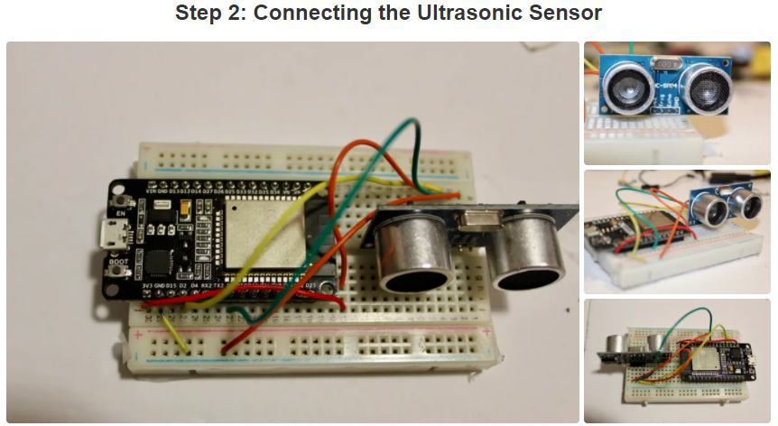

(The picture shows 3.3V and VCC, use the 5V pin instead)

### Part 2 Reading via Serial Monitor:

Copy and upload the code provided with this lab to the esp32. Once the code is successfully uploaded, open a serial monitor through Arduino IDE by clicking the serial monitor button in the top right corner. You should see another window open that provides data from the ultrasonic sensor. **Make sure that the baud rate is set to 115200 or else you will see nothing in the serial monitor.** The baud rate is the rate information is based through. Try moving the sensor around and get a feel for the range and how accurate it is. Make sure it works correctly or else your car will not be able to stop in the next lab.

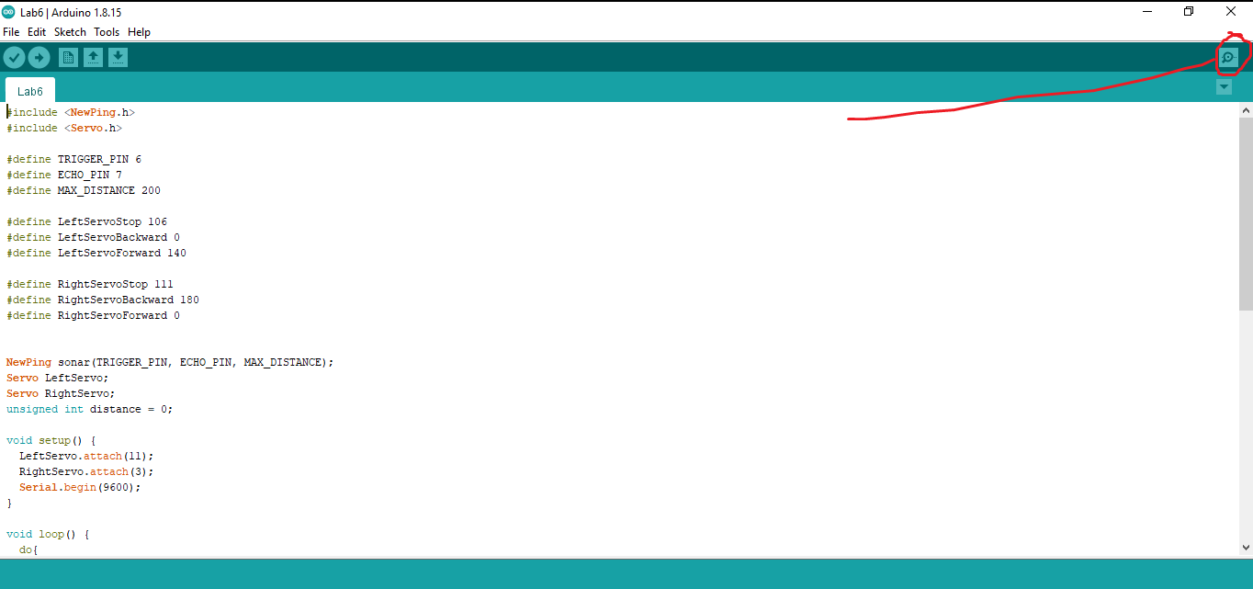

### Part 3 Reading via BT:

Now we will do the same thing as before but connect via Bluetooth. Copy the same circuit as in part 2. Copy and upload the other code provided with the lab to the esp32. Connect via Bluetooth using the serial app. It should show the same readings as the serial monitor. You can turn the sensor on and off by sending “HC-SR04_on” and “HC-SR04_off” respectively.